# Lab 05C: Configuring Out-of-the-box Branding

**Lab Overview:** In this lab you will explore some simple things you can do to make your site not look so much like SharePoint. First you will apply an out of the box theme and upload a custom graphic to give the site a quick make over. Then you will change the master page to get an idea of what is involved in the process.

## Exercise 1: Setting HR to use a different theme

Betsy has called and she would like to change the look of the HR Private site. For some reason she wants a flag theme.

1. Navigate to the HR Private site logged in as Betsy
   1. Open **http://portal.tpg.local/sites/hr**
   2. **tpg\betsy**
   3. **pass@word1**
   4. **OK**
2. Create a picture library called images
   1. Click Site Actions > **Create**
   2. Under Libraries choose **Picture Library**
   3. Name = **Images**
   4. Display the picture library on the Quick Launch? = **No**
   5. Click **Create**
3. Upload the custom graphic
   1. Click **Upload**
   2. Click **Browse…**
   3. Navigate to **c:\_Student Files\Module 5**
   4. Click **USA.png**
   5. Click **Open**
   6. Click **OK**
   7. On the properties screen take the default and click **OK**
4. Change the theme
   1. Click Site Actions > **Site Settings**
   2. Under Look and Feel click **Site theme**
   3. All of the themes have preview images. Browse the collection to get an idea of what is available. Once you are done looking around choose the **Classic theme** and click **Apply**
5. Notice the colors changed right away. Now you need to change the people logo beside HR Team 
   1. Under the Look and Feel column click **Title, description, and icon**
   2. Change the URL to **/sites/hr/images1/usa.png** Notice the 1 in images1. This is because there is already and images folder so SharePoint is smart enough to change the name of the folder when you created the images list.
   3. Click **OK**
   4. Click the **Home** tab

Betsy now has a decent looking site without too much work.

## Exercise 2: Changing the master page

Site themes are great for changing the way that a site looks quickly but sometimes you need to change the physical structure of the page. This is where master pages come into play.

1. Navigate to the home page of the TPG portal by entering the URL **http://portal.tpg.local**
2. Sign in as **Alan**
   1. Click **Welcome Betsy Ross**
   2. Click **Sign in as Different user**
   3. **TPG\alan**
   4. **pass@word1**
   5. Click **OK**
3. Click Site Actions > Site Settings > **Modify All Site Settings**
4. Under Look and Feel click **Master page**
5. There are 3 changes you can make from this page. The Site Master Page, the System Master Page, and the CSS file. Try changing just the Site Master Page to see what happens.
   1. For Site Master Page change default.master to **OrangeSingleLevel.master**
   2. Scroll down the page and click **OK**
   3. Notice the page you are on has not changed. Click the **The TPG Portal** tab to check out the home page.

Completely different. You have a different color palette, the quick launch bar is visible, and if you scroll down the page you will see a footer with the address. What hasn’t changed though? The content and web parts.

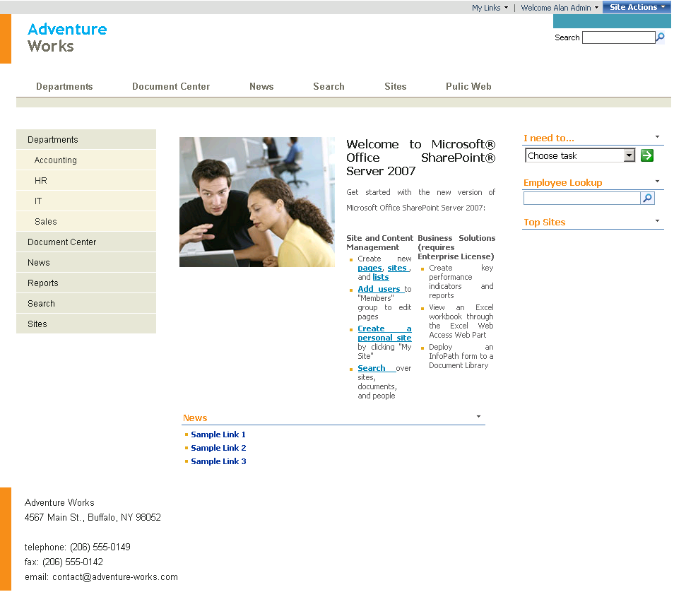

1. Click Site Actions > **View All Site Content**
2. This page hasn’t changed. Now click **Documents**
3. Still looks the same. Try changing the system master to see what happens.
   1. Click Site Actions > Site Settings > **Modify All Site Settings**
   2. Under Look and Feel click **Master page**
   3. Set System Master Page to **OrangeSingleLevel.master**
   4. Click **OK**
4. Site Settings page still the same. Click Site Actions > **View All Site Content**
5. All Site Content still the same. Click **Documents**

Hooray! A page that has changed. System Master affects all of the list and library view pages. The reason that the other 2 pages have not changed is because they are driven by Application master. Application master affects all pages that are in the /_layouts folder. This is also where this file resides. The trouble with changing this file is it is NOT SUPPORTED and it will affect all sites on the whole server. A better solution would be to just brand the pages with a custom CSS file. This can be applied from the same screen you changed the default and system master.

1. Set the site back to the way it was.
   1. Click Site Actions > Site Settings > **Modify All Site Settings**
   2. Under Look and Feel click **Master page**
   3. Set Site Master Page to **default.master**
   4. Set System Master Page to **default.master**
   5. Click **OK**

Now everything is back to normal.

## End of lab